***1. Program to write the first 10 numbers.***

for (let i = 0; i <=10; i++) {

console.log(i)

}

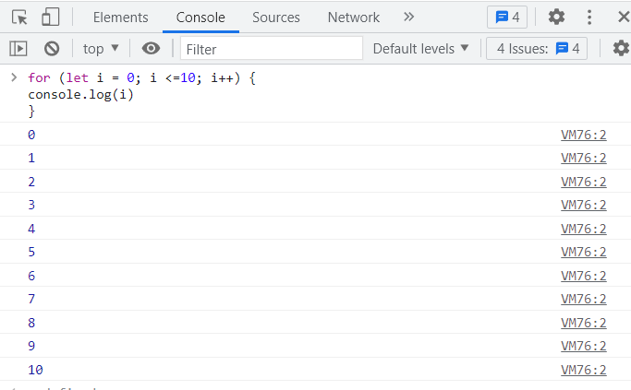

***2. Program to calculate the sum of first 10 numbers***

let s = 0;

for (let i = 0; i <=10; i++) {

s = s+i ;

console.log(s)

}

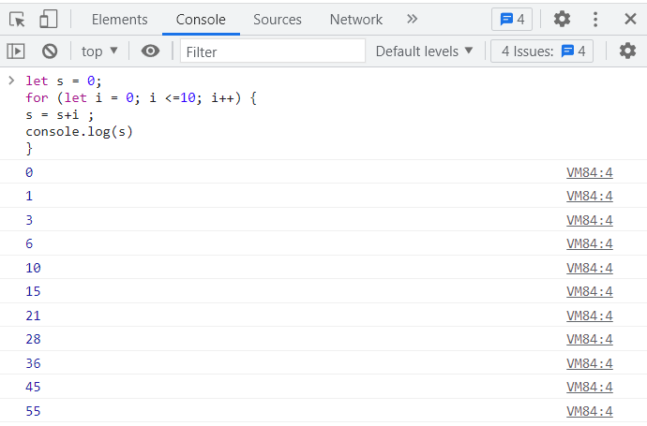

***3. Make the loop stop when i is 5.***

for (i = 0; i < 10; i++) {  
console.log(i);  
if (i == 5) {   
  
break;  
}  
}

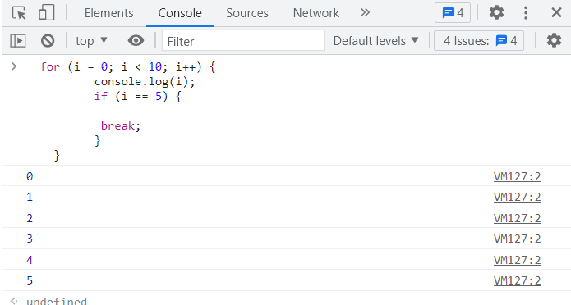

***4. Write a program to print day of week name using switch case.***

let day = 6;

switch (day) {

case 1:

day = 'Sunday';

break;

case 2:

day = 'Monday';

break;

case 3:

day = 'Tuesday';

break;

case 4:

day = 'Wednesday';

break;

case 5:

day = 'Thursday';

break;

case 6:

day = 'Friday';

break;

case 7:

day = 'Saturday';

break;

default:

day = 'Invalid day';

}

console.log(day);

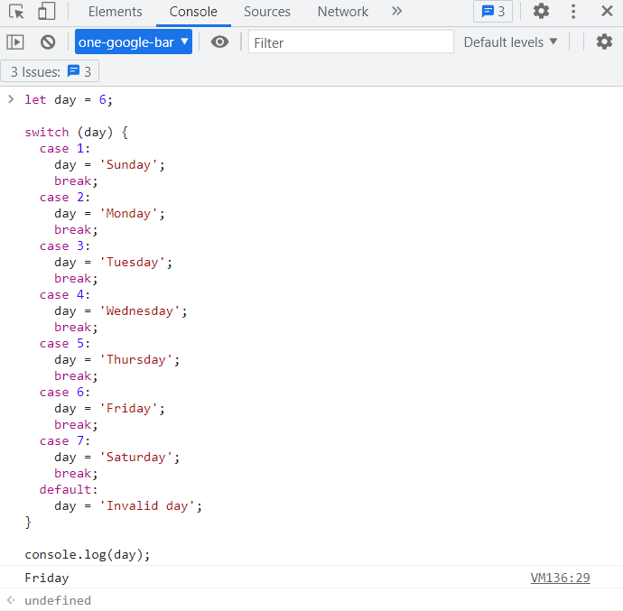

***5. Write a program print total number of days in a month using switch case.***

let year = 2016;

let month = 2;

let dayCount;

switch (month) {

case 1:

case 3:

case 5:

case 7:

case 8:

case 10:

case 12:

dayCount = 31;

break;

case 4:

case 6:

case 9:

case 11:

dayCount = 30;

break;

case 2:

if ((year % 4 == 0 && !(year % 100 == 0)) || year % 400 == 0) {

dayCount = 29;

} else {

dayCount = 28;

}

break;

default: dayCount = -1;

}

console.log(dayCount);

